EXPERIMENT-3
NAME: Yuvaraj A ROLL NO:240701809
1.COMMAND LINE INTERFACE:
PYTHON CODE:
from datetime import datetime now = datetime.now() current_time = now.strftime("%d-%m-%Y %I:%M:%S %p") print("Current Date and Time:", current_time) OUTPUT:
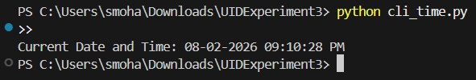
2.GRAPHICAL USER INTERFACE:
PYTHON CODE:
import tkinter as tk from datetime import datetime def show_time():
now = datetime.now() current_time = now.strftime("%d-%m-%Y %I:%M:%S %p") label.config(text=current_time) root = tk.Tk() root.title("Date and Time") root.geometry("300x150") btn = tk.Button(root, text="Show Date & Time", command=show_time) btn.pack(pady=10) label = tk.Label(root, text="") label.pack() root.mainloop()

OUTPUT:
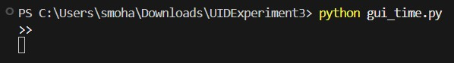
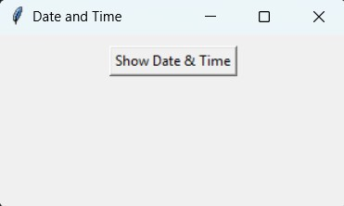
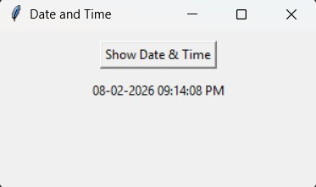

3.VOICE USER INTERFACE:
PYTHON CODE:
import pyttsx3 from datetime import datetime engine = pyttsx3.init() now = datetime.now() date_time = now.strftime("%d %B %Y, %I:%M %p") message = "Current date and time is " + date_time print(message) engine.say(message) engine.runAndWait() import pyttsx3 from datetime import datetime engine = pyttsx3.init() now = datetime.now() date_time = now.strftime("%d %B %Y, %I:%M %p") message = "Current date and time is " + date_time print(message) engine.say(message) engine.runAndWait()

OUTPUT:
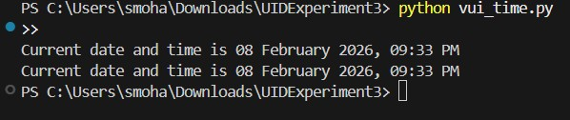

4.USER SATISFACTION COMPARISON:
PYTHON CODE:
print("User Satisfaction Survey (Rate from 1 to 5)") print("1 = Very Poor, 5 = Excellent\n") cli = int(input("Rate CLI experience: ")) gui = int(input("Rate GUI experience: ")) vui = int(input("Rate VUI experience: ")) ratings = {
"CLI": cli,
"GUI": gui,
"VUI": vui
} average = (cli + gui + vui) / 3 best_interface = max(ratings, key=ratings.get) print("\n--- Satisfaction Results ---") print("CLI Rating:", cli) print("GUI Rating:", gui) print("VUI Rating:", vui) print("Average Rating:", round(average, 2)) print("Most Preferred Interface:", best_interface)

OUTPUT:
